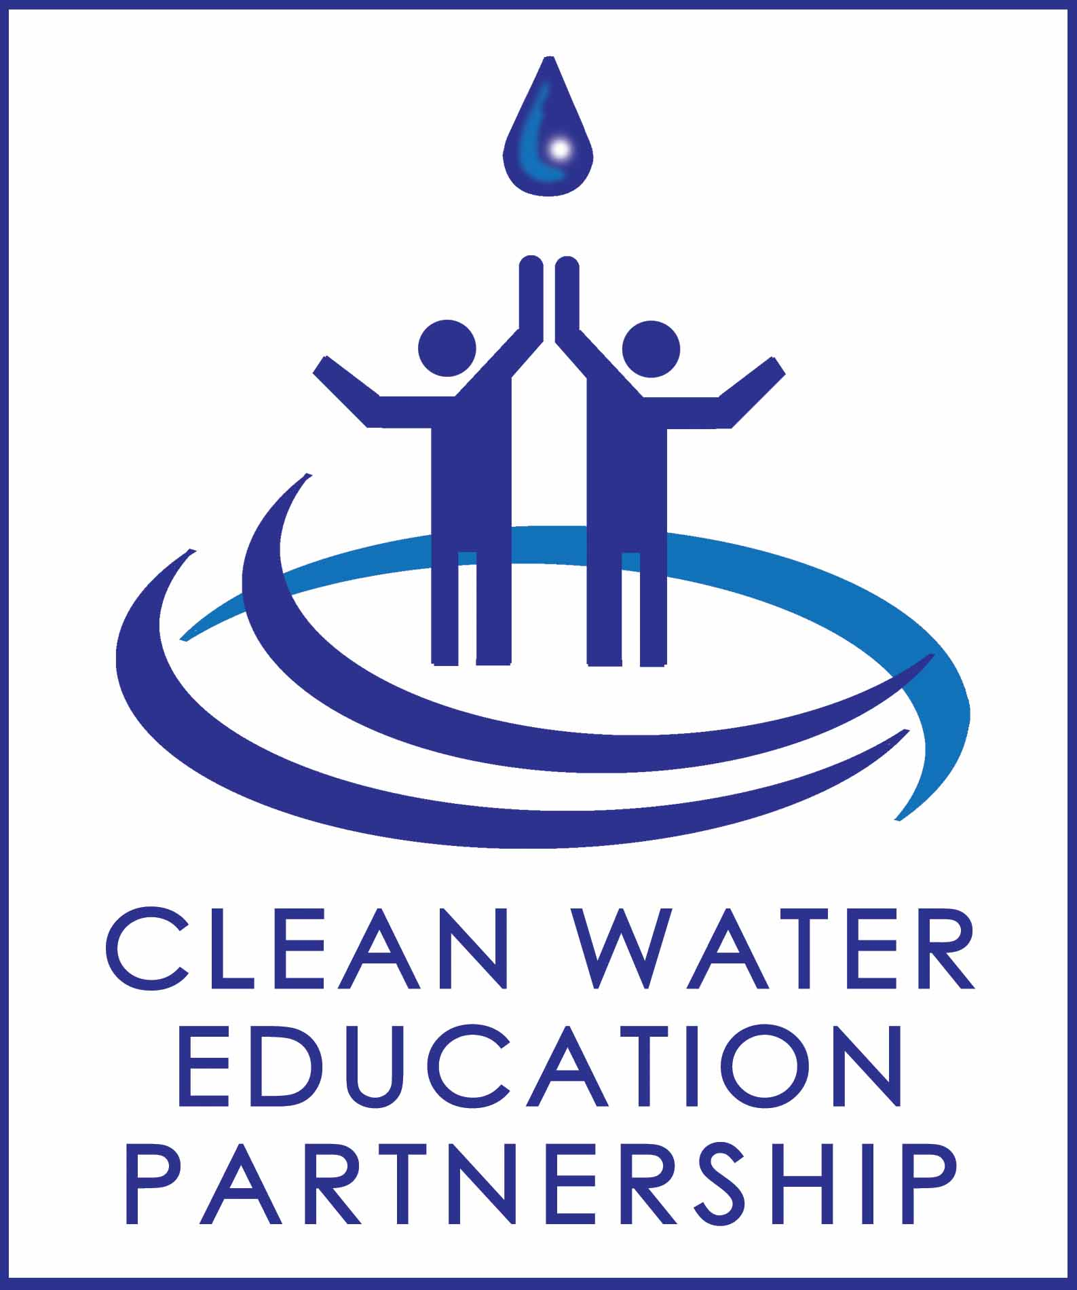
SUMMARY

CLEAN WATER EDUCATION PARTNERSHIP
www.ncCleanWater.org

STEERING COMMITTEE MEETING

April 9, 2019
Triangle J Council of Governments, Durham NC

Present
James Misciagno, Town of Apex
Jessica Gladwin, Town of Butner
Heather Holley, Town of Carrboro
Charles Brown, Town of Cary
Marie Cefalo, Town of Cary
Allison Schwarz-Weakley, Town of Chapel Hill
Drew Blake, Chatham County
Laura Webb Smith, City of Durham
McKenzie Gentry, Durham County
Terry Hackett, Town of Hillsborough
Zachary Pitts, Town of Holly Springs
Tony Victor, Town of Morrisville
Carmela Teichman, City of Raleigh
Amy Farinelli, City of Raleigh
Phil Ross, City of Roxboro
Jen Schmitz, TJCOG
Blair Frantz, TJCOG
Maya Cough-Schulze, TJCOG
Danica Heflin, PTRC
Lindsey Lengyel, BlueStream Environmental
Marguerite Bishop, Town of Nashville
Julie Spriggs, Town of Nashville
Jaclyn Stannard, Town of Garner
On the Conference Line
Karen Durham, Town of Clayton
Jennifer Mitchell, Town of Fuquay-Varina
TJ Cawley, Town of Morrisville

FY19 Program Updates
Jen introduced new Water Program staff member Maya, gave a brief overview of the La Noticia ad campaign, CBC/Spectrum Campaigns and giveaway Blair and Maya have received from local businesses as incentives to interact with the CWEP website. Maya informed the group that she attended the March 26th Phase II NPDES workshop. Danica Heflin updated the group on PTRC’s involvement. Stormwater SMART is interested in participating in CWEP next fiscal year, and Danica will help train CWEP’s AmeriCorps next year as PTRC did with Blair. Additionally, SMART learned that Sesame Street does stormwater education for families of young children, and in the coming year will use their mobile classroom to deliver this education in communities. Danica offered to pilot this in the TJCOG region.

Direct Education in FY19
Blair Frantz, 2019 AmeriCorps Service Member, gave a presentation to the Partners about her work thus far on direct education and outreach for the CWEP program. She updated the members on all the possible environmental education activities and materials she has at her disposal, including those generously donated by CWEP members.

She has continued to update an extensive Excel spreadsheet of all events in all 37 jurisdictions that can be used for years to come. Please email her at bfrantz@tjcog.org if you would like to add any events to the spreadsheet. She is on track to reach her goal of doing outreach in each of the 37 entities at least once this service year. She is recording the numbers of individuals reached at these events, which will be included in the CWEP annual report. All tracking materials, spreadsheets, and other resources Blair referenced are available here: CWEP Partners Site

She has also applied on behalf of the CWEP program for several small grants for storm drain marking and has been organizing tips/informal SOP information for the next AmeriCorps volunteer.

Stormwater Outreach Tool Demo

James Misciagno did a demonstration and played videos of kids interacting with his 3D-printed model that shows the path of stormwater from a storm drain in front of a house into a creek. He pointed out that the model is a smaller, more local scale than an Enviroscape, and thus is easier for people to relate to than a whole watershed. His goal is for the models ultimately to be less than $500.

Draft FY20 Budget/Cost Shares

Jen gave a brief overview of FY20 budget/cost shares. There will be less of CWEP total revenue allocated towards staff time, but more staff time devoted to CWEP, as Maya’s time will largely replace Jen’s. Jen also slightly increased some AmeriCorps line items based on how this year’s budget worked out.

Future Cost Share Scenario Presentation/Discussion

Maya presented a range of ways TJCOG could garner increased CWEP revenues and improve services CWEP delivers to the members. Improved services could include sustainable funding for AmeriCorps direct education (currently paid partly out of fund balance that will be depleted within a couple years); increased Spanish language programs/materials; increased mass media; or other ideas from members. Maya outlined scenarios for how per capita or base costs could be incrementally increased based on population to provide revenue to accomplish these improvements.

A smaller CWEP member expressed support for increasing the per capita rate to FY09 levels over two years. There was concern among larger CWEP members that any cost share increase would not be feasible. Members generally agreed that they would rather try to grow revenue by finding new members than increasing cost shares.

Lindsey Lengyel asked what CWEP members’ highest priority for CWEP would be if there were increased revenues available. Discussion and an informal show of hands showed that CWEP members’ priorities are about evenly split between Spanish language print materials (potentially specific to construction and erosion control), direct education, and website/social media improvements.

The meeting adjourned at 11:55 am.

